WEEKLY WORSHEET OF (CSE)

**SUBMITTED BY:** Soham Rajawat

**Roll no.** 2315002180

**Class/Section** Ay-2

**WORKSHEET WEEK 1**

Q1. Write a program to accept height and base of triangle and calculate area of Triangle Note: area =(h*b)/2.

Ans

#include <stdio.h>

int main() {

float height, base;

printf("Enter the height of the triangle: ");

scanf("%f", &height);

printf("Enter the base of the triangle: ");

scanf("%f", &base);

float area = (height * base) / 2;

printf("The area of the triangle is: %.2f\n", area);

return 0;

}

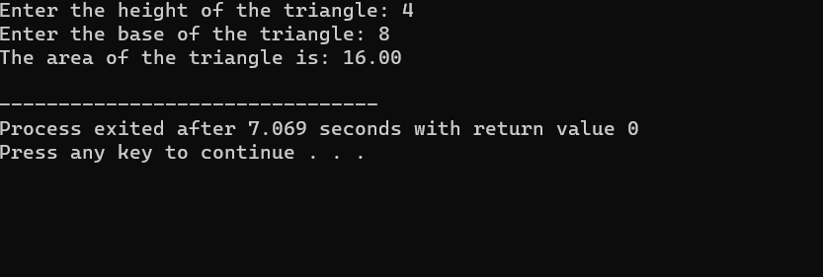

Q.2 Write a program to accept radius of circle and calculate area of circle Note: area =pi * r2

Ans.

#include <stdio.h>

#include <math.h>

#define PI 3.14

int main() {

float radius;

printf("Enter the radius of the circle: ");

scanf("%f", &radius);

float area = PI * pow(radius, 2);

printf("The area of the circle is: %.2f\n", area);

return 0;

}

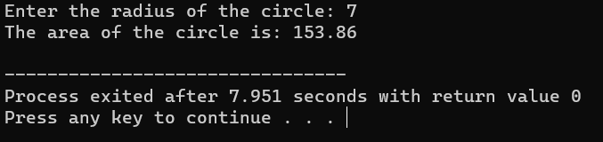

Q. Write a program to find the lowest marks of three students using conditional operator.

Ans.

#include <stdio.h>

int main() {

int marks1, marks2, marks3;

printf("Enter marks for student 1: ");

scanf("%d", &marks1);

printf("Enter marks for student 2: ");

scanf("%d", &marks2);

printf("Enter marks for student 3: ");

scanf("%d", &marks3);

int lowestMarks = (marks1 < marks2) ? ((marks1 < marks3) ? marks1 : marks3) : ((marks2 < marks3) ? marks2 : marks3);

printf("The lowest marks among the three students is: %d\n", lowestMarks);

return 0;

}

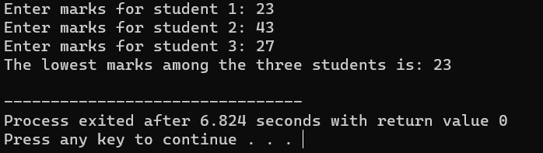

Q. Write a program to Calculate Compound Interest.

Ans.

#include <stdio.h>

#include <math.h>

int main() {

float principal, rate, time, compoundInterest;

printf("Enter the principal amount: ");

scanf("%f", &principal);

printf("Enter the rate of interest (in percentage): ");

scanf("%f", &rate);

printf("Enter the time (in years): ");

scanf("%f", &time);

compoundInterest = principal * pow((1 + rate / 100), time) - principal;

printf("Compound Interest: %.2f\n", compoundInterest);

return 0;

}

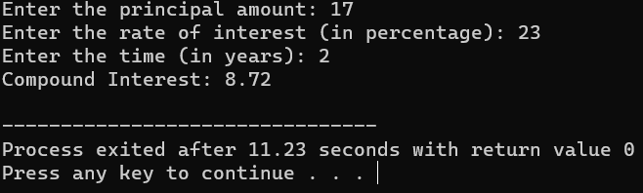

Q5. Write a program to Calculate Cube of a Number.

Ans.

#include <stdio.h>

int main() {

int number, cube;

printf("Enter a number: ");

scanf("%d", &number);

cube = number * number * number;

printf("The cube of %d is: %d\n", number, cube);

return 0;

}

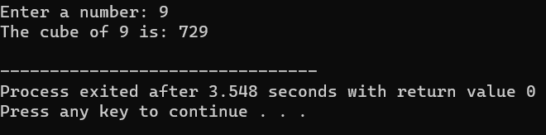

**WORKSHEET WEEK 2**

Q.1 Write a program to interchange two values by using Assignment Operator.

Ans.

#include <stdio.h>

int main() {

int a, b;

printf("Enter the value of a: ");

scanf("%d", &a);

printf("Enter the value of b: ");

scanf("%d", &b);

a = a + b;

b = a - b;

a = a - b;

printf("After interchange:\n");

printf("a: %d\n", a);

printf("b: %d\n", b);

return 0;

}

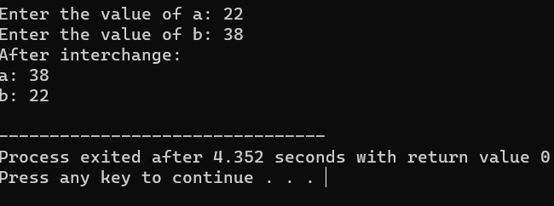

Q. Write a program to interchange two values by using Arithmetic Operator.

Ans.

#include <stdio.h>

int main() {

int a, b;

printf("Enter the value of a: ");

scanf("%d", &a);

printf("Enter the value of b: ");

scanf("%d", &b);

a = a + b;

b = a - b;

a = a - b;

printf("After interchange:\n");

printf("a: %d\n", a);

printf("b: %d\n", b);

return 0;

}

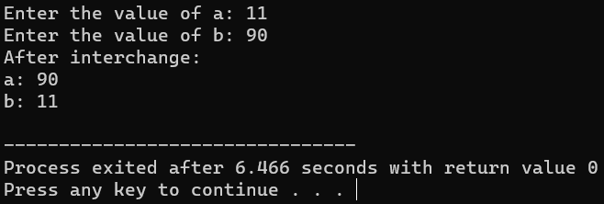

Q. Write a program to interchange two values by using Bitwise Operator.

Ans.

#include <stdio.h>

int main() {

int a, b;

printf("Enter the value of a: ");

scanf("%d", &a);

printf("Enter the value of b: ");

scanf("%d", &b);

a = a ^ b;

b = a ^ b;

a = a ^ b;

printf("After interchange:\n");

printf("a: %d\n", a);

printf("b: %d\n", b);

return 0;

}

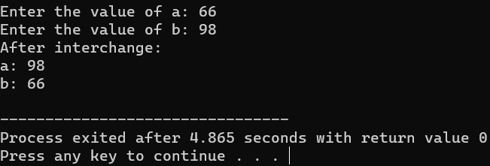

Q. Write a program to find the size of all data types (Int, Float, Char, Double, Long Double, Short Int etc.).

Ans.

#include <stdio.h>

int main() {

printf("Size of int: %lu bytes\n", sizeof(int));

printf("Size of float: %lu bytes\n", sizeof(float));

printf("Size of char: %lu bytes\n", sizeof(char));

printf("Size of double: %lu bytes\n", sizeof(double));

printf("Size of long double: %lu bytes\n", sizeof(long double));

printf("Size of short int: %lu bytes\n", sizeof(short int));

printf("Size of long int: %lu bytes\n", sizeof(long int));

printf("Size of unsigned int: %lu bytes\n", sizeof(unsigned int));

printf("Size of long long int: %lu bytes\n", sizeof(long long int));

return 0;

}

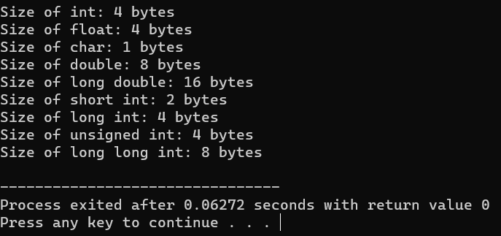

Q. Write a program to find out whether input number is even or odd without using arithmetic operators.

Ans.

#include <stdio.h>

int isEven(int num) {

// Using bitwise AND operator to check the least significant bit

return (num & 1) == 0;

}

int main() {

int number;

// Prompt user for input

printf("Enter a number: ");

scanf("%d", &number);

// Check if the number is even or odd using the isEven function

if (isEven(number)) {

printf("%d is even.\n", number);

} else {

printf("%d is odd.\n", number);

}

return 0;

}

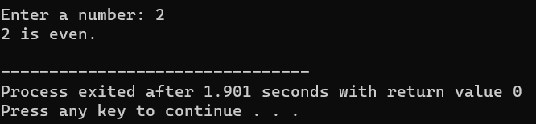

**WORKSHEET WEEK 3**

Q. Write a C program to check whether a given number is even or odd.

Ans.

#include <stdio.h>

int main() {

int number;

printf("Enter a number: ");

scanf("%d", &number);

if (number % 2 == 0) {

printf("%d is even.\n", number);

} else {

printf("%d is odd.\n", number);

}

return 0;

}

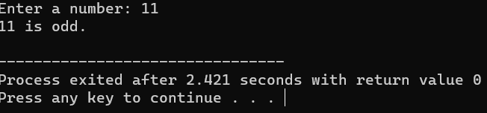

Q. Write a C program to check whether a given number is positive or negative.

Ans.

#include <stdio.h>

int main() {

int number;

printf("Enter a number: ");

scanf("%d", &number);

if (number > 0) {

printf("%d is positive.\n", number);

} else if (number < 0) {

printf("%d is negative.\n", number);

} else {

printf("The number is zero.\n");

}

return 0;

}

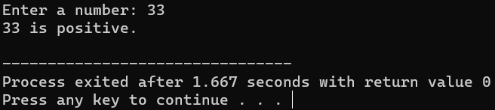

Q. Write a C program to find whether a given year is a leap year or not.

Ans.

#include <stdio.h>

int main() {

int year;

printf("Enter a year: ");

scanf("%d", &year);

if ((year % 4 == 0 && year % 100 != 0) || (year % 400 == 0)) {

printf("%d is a leap year.\n", year);

} else {

printf("%d is not a leap year.\n", year);

}

return 0;

}

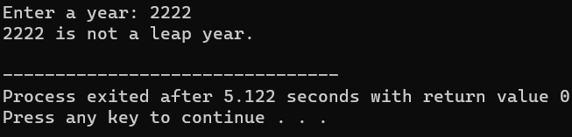

Q. Write a C program to find the largest of three numbers.

Ans.

#include <stdio.h>

int main() {

int num1, num2, num3;

printf("Enter three numbers: ");

scanf("%d %d %d", &num1, &num2, &num3);

int largest = (num1 > num2) ? ((num1 > num3) ? num1 : num3) : ((num2 > num3) ? num2 : num3);

printf("The largest number is: %d\n", largest);

return 0;

}

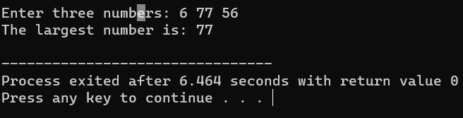

Q. Write a C program to read temperature in centigrade and display a suitable message.

Ans.

#include <stdio.h>

int main() {

float temperature;

printf("Enter the temperature in centigrade: ");

scanf("%f", &temperature);

if (temperature < 0) {

printf("Freezing weather.\n");

} else if (temperature >= 0 && temperature <= 10) {

printf("Very Cold weather.\n");

} else if (temperature > 10 && temperature <= 20) {

printf("Cold weather.\n");

} else if (temperature > 20 && temperature <= 30) {

printf("Normal in Temp.\n");

} else if (temperature > 30 && temperature <= 40) {

printf("It's Hot.\n");

} else {

printf("It's Very Hot.\n");

}

return 0;

}

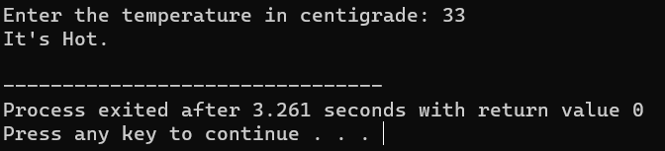

Q. Write a C program to read any digit and display it in the word.

Ans

#include <stdio.h>

int main() {

int digit;

printf("Enter a digit (0-9): ");

scanf("%d", &digit);

switch (digit) {

case 0:

printf("Zero\n");

break;

case 1:

printf("One\n");

break;

case 2:

printf("Two\n");

break;

case 3:

printf("Three\n");

break;

case 4:

printf("Four\n");

break;

case 5:

printf("Five\n");

break;

case 6:

printf("Six\n");

break;

case 7:

printf("Seven\n");

break;

case 8:

printf("Eight\n");

break;

case 9:

printf("Nine\n");

break;

default:

printf("Invalid digit\n");

}

return 0;

}

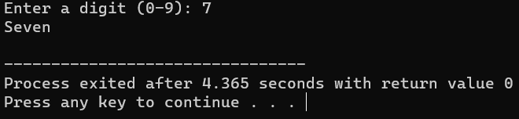

Q. Write a C program to create a Simple Calculator using a switch case.

Ans

#include <stdio.h>

int main() {

char Operator;

double num1, num2;

printf("Enter an Operator (+, -, *, /): ");

scanf(" %c", &Operator);

printf("Enter two numbers: ");

scanf("%lf %lf", &num1, &num2);

switch (Operator) {

case '+':

printf("%.2f + %.2f = %.2f\n", num1, num2, num1 + num2);

break;

case '-':

printf("%.2f - %.2f = %.2f\n", num1, num2, num1 - num2);

break;

case '*':

printf("%.2f * %.2f = %.2f\n", num1, num2, num1 * num2);

break;

case '/':

if (num2 != 0) {

printf("%.2f / %.2f = %.2f\n", num1, num2, num1 / num2);

} else {

printf("Error! Division by zero.\n");

}

break;

default:

printf("Invalid Operator.\n");

}

return 0;

}

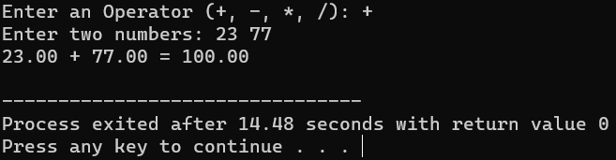

Q. Write a C program using C Switch…Case to Calculate the Area of Rectangle/Circle/Triangle.

Ans.

#include <stdio.h>

#define PI 3.14

int main() {

int choice;

int area, base, height, radius;

printf("Choose a shape to calculate its area:\n");

printf("1. Rectangle\n");

printf("2. Circle\n");

printf("3. Triangle\n");

printf("Enter your choice (1, 2, or 3): ");

scanf("%d", &choice);

switch (choice) {

case 1:

printf("Enter the length of the rectangle: ");

scanf("%d", &base);

printf("Enter the width of the rectangle: ");

scanf("%d", &height);

area = base * height;

printf("Area of the rectangle: %d\n", area);

break;

case 2:

printf("Enter the radius of the circle: ");

scanf("%d", &radius);

area = PI * radius * radius;

printf("Area of the circle: %d\n", area);

break;

case 3

printf("Enter the base of the triangle: ");

scanf("%d", &base);

printf("Enter the height of the triangle: ");

scanf("%d", &height);

area = base * height / 2;

printf("Area of the triangle: %d\n", area);

break;

default:

printf("Invalid choice. Please enter 1, 2, or 3.\n");

}

return 0;

}

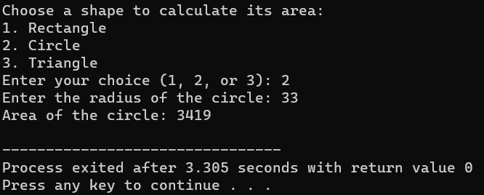

Q. Write a C program to calculate the sum and average of positive numbers.

Ans.

#include <stdio.h>

int main() {

int num, count = 0, sum = 0;

printf("Enter positive numbers (enter a negative number to finish):\n");

while (1) {

printf("Enter a number: ");

scanf("%d", &num);

if (num < 0) {

break;

}

sum += num;

count++;

}

if (count > 0) {

int average = sum / count;

printf("Sum: %d\n", sum);

printf("Average: %d\n", average);

} else {

printf("No positive numbers were entered.\n");

}

return 0;

}

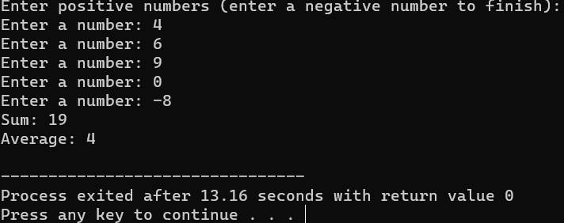

Q.

Ans.

#include <stdio.h>

#include <stdlib.h>

#include <unistd.h>

#include <time.h>

int main() {

int hours, minutes, seconds;

while (1) {

system("clear");

time_t now;

time(&now);

hours = (now / 3600) % 24;

minutes = (now / 60) % 60;

seconds = now % 60;

printf("Digital Clock: %02d:%02d:%02d\n", hours, minutes, seconds);

sleep(1);

}

return 0;

}

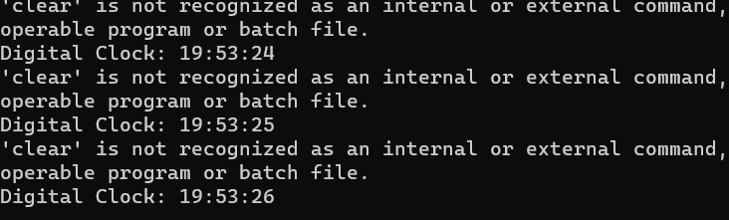

**WORKSHEET WEEK 4**

Q. Write a C program to print multiplication table of a number.

Ans.

#include <stdio.h>

int main() {

int num, i;

printf("Enter a number: ");

scanf("%d", &num);

printf("Multiplication table for %d:\n", num);

for (i = 1; i <= 10; ++i) {

printf("%d x %d = %d\n", num, i, num * i);

}

return 0;

}

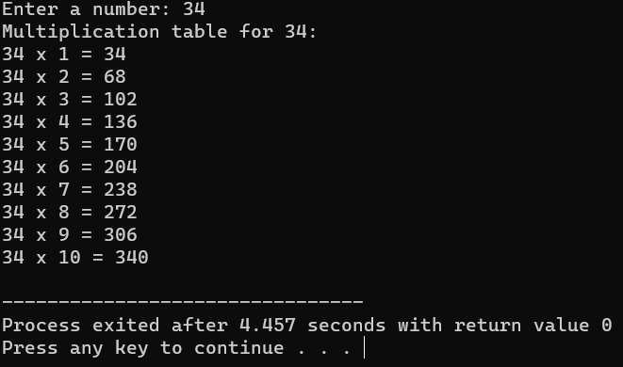

Q. Write a C program to calculate factorial of a number.

Ans.

#include <stdio.h>

int factorial(int n) {

if (n == 0 || n == 1) {

return 1;

} else {

return n * factorial(n - 1);

}

}

int main() {

int num;

printf("Enter a number: ");

scanf("%d", &num);

printf("Factorial of %d is: %d\n", num, factorial(num));

return 0;

}

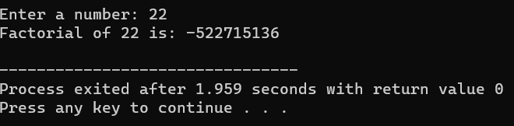

Q. Write a C program to check whether a number is palindrome or not.

Ans.

#include <stdio.h>

int isPalindrome(int num) {

int reversed = 0, original = num;

while (num != 0) {

reversed = reversed * 10 + num % 10;

num /= 10;

}

return reversed == original;

}

int main() {

int num;

printf("Enter a number: ");

scanf("%d", &num);

if (isPalindrome(num)) {

printf("%d is a palindrome.\n", num);

} else {

printf("%d is not a palindrome.\n", num);

}

return 0;

}

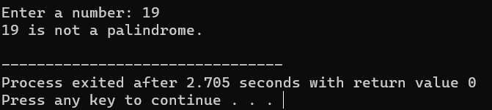

Q. Write a C program to count frequency of digits in a given number.

Ans

#include <stdio.h>

int isPalindrome(int num) {

int reversed = 0, original = num;

while (num != 0) {

reversed = reversed * 10 + num % 10;

num /= 10;

}

return reversed == original;

}

int main() {

int num;

printf("Enter a number: ");

scanf("%d", &num);

if (isPalindrome(num)) {

printf("%d is a palindrome.\n", num);

} else {

printf("%d is not a palindrome.\n", num);

}

return 0;

}

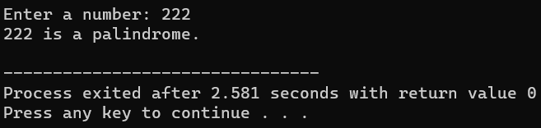

Q. Write a C program to find HCF(GCD) AND LCM of two numbers.

Ans.

#include <stdio.h>

void countDigits(int num) {

int count[10] = {0};

while (num != 0) {

count[num % 10]++;

num /= 10;

}

printf("Digit frequency:\n");

for (int i = 0; i < 10; ++i) {

if (count[i] > 0) {

printf("%d: %d times\n", i, count[i]);

}

}

}

int main() {

int num;

printf("Enter a number: ");

scanf("%d", &num);

countDigits(num);

return 0;

}

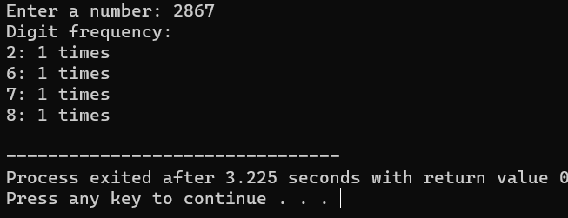

Q.

Ans.

#include <stdio.h

int findGCD(int a, int b) {

while (a != b) {

if (a > b) {

a -= b;

} else {

b -= a;

}

}

return a;

}

int findLCM(int a, int b) {

return (a * b) / findGCD(a, b);

}

int main() {

int num1, num2;

printf("Enter two numbers: ");

scanf("%d %d", &num1, &num2);

printf("GCD of %d and %d is: %d\n", num1, num2, findGCD(num1, num2));

printf("LCM of %d and %d is: %d\n", num1, num2, findLCM(num1, num2));

return 0;

}

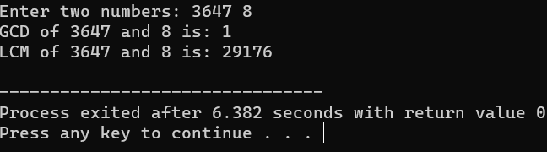

Q. Write a C program to print all prime numbers between 1 to n.

Ans.

#include <stdio.h>

int isPrime(int num) {

if (num < 2) {

return 0;

}

for (int i = 2; i * i <= num; ++i) {

if (num % i == 0) {

return 0;

}

}

return 1;

}

int main() {

int n;

printf("Enter a number (n): ");

scanf("%d", &n);

printf("Prime numbers between 1 and %d are:\n", n);

for (int i = 2; i <= n; ++i) {

if (isPrime(i)) {

printf("%d\n", i);

}

}

return 0;

}

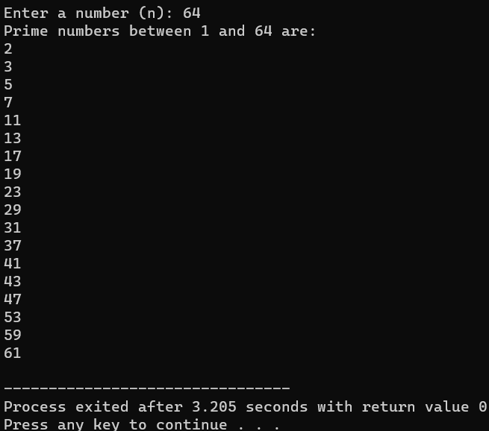

Q. Write a C program to print Fibonacci series up to n terms.

Ans.

#include <stdio.h>

void fibonacci(int n) {

int a = 0, b = 1, next;

printf("Fibonacci series up to %d terms:\n", n);

for (int i = 0; i < n; ++i) {

printf("%d, ", a);

next = a + b;

a = b;

b = next;

}

}

int main() {

int terms;

printf("Enter the number of terms: ");

scanf("%d", &terms);

fibonacci(terms);

return 0;

}

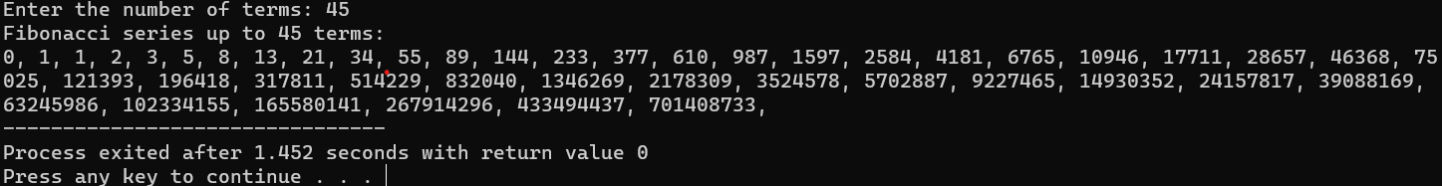

Q. Write a C program to print Armstrong numbers from 1 to n AND check a given number is Armstrong numbers or not.

Ans.

#include <stdio.h>

#include <math.h>

int isArmstrong(int num) {

int original = num, result = 0, n = 0;

while (original != 0) {

original /= 10;

++n; }

original = num;

while (original != 0) {

int remainder = original % 10;

result += pow(remainder, n);

original /= 10;

}

return result == num;

}

int main() {

int num;

printf("Enter a number: ");

scanf("%d", &num);

if (isArmstrong(num)) {

printf("%d is an Armstrong number.\n", num);

} else {

printf("%d is not an Armstrong number.\n", num);

}

return 0;

}

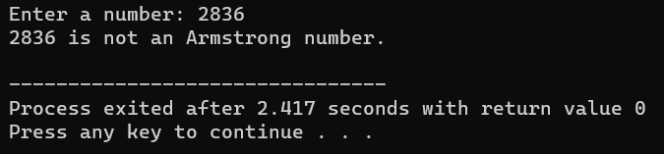

Q.

Ans.

#include <stdio.h>

int isPerfect(int num) {

int sum = 0;

for (int i = 1; i <= num / 2; ++i) {

if (num % i == 0) {

sum += i;

}

}

return sum == num;

}

void printPerfectNumbers(int n) {

printf("Perfect numbers between 1 and %d are:\n", n);

for (int i = 1; i <= n; ++i) {

if (isPerfect(i)) {

printf("%d\n", i);

}

}

}

int main() {

int num;

printf("Enter a number: ");

scanf("%d", &num);

if (isPerfect(num)) {

printf("%d is a Perfect number.\n", num);

} else {

printf("%d is not a Perfect number.\n", num);

}

return 0;

}

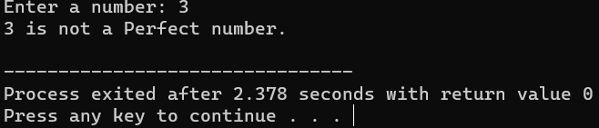

Q. Write a C program to print all Strong Numbers between 1 to n.

Ans

#include <stdio.h>

int factorial(int n) {

if (n == 0 || n == 1) {

return 1;

} else {

return n * factorial(n - 1);

}

}

int isStrong(int num) {

int original = num, sum = 0;

while (num != 0) {

int digit = num % 10;

sum += factorial(digit);

num /= 10;

}

return sum == original;

}

void printStrongNumbers(int n) {

printf("Strong numbers between 1 and %d are:\n", n);

for (int i = 1; i <= n; ++i) {

if (isStrong(i)) {

printf("%d\n", i);

}

}

}

int main() {

int num;

printf("Enter a number: ");

scanf("%d", &num);

printStrongNumbers(num);

return 0;

}

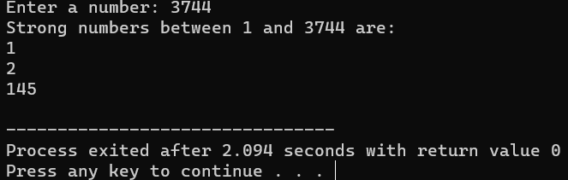

**WORKSHEET WEEK 5**

Pattern A

#include <stdio.h>

int main() {

printf("a.\n");

for (int i = 5; i >= 1; i--) {

for (int j = 1; j <= i; j++) {

printf("%d", j);

}

printf("\n");

}

return 0;

}

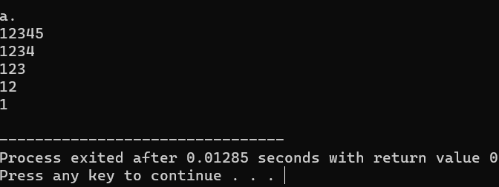

Pattern B

#include <stdio.h>

int main() {

printf("b.\n");

for (int i = 5; i >= 1; i--) {

for (int j = 1; j <= 5; j++) {

printf("%d", j);

}

printf("\n");

}

return 0;

}

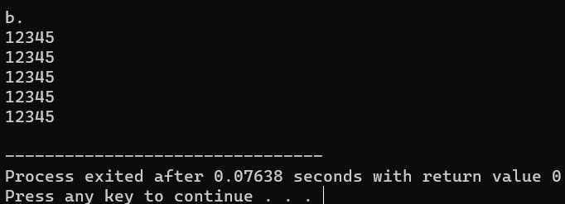

Pattern C

#include <stdio.h>

int main() {

printf("c.\n");

for (int i = 1; i <= 4; i++) {

for (int j = 1; j <= i; j++) {

printf("%d", i);

}

printf("\n");

}

return 0;

}

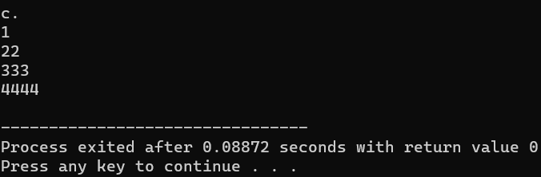

Pattern D

#include <stdio.h>

int main() {

printf("d.\n");

for (int i = 1; i <= 4; i++) {

for (int j = 1; j <= i; j++) {

printf("%d", j);

}

printf("\n");

}

return 0;

}

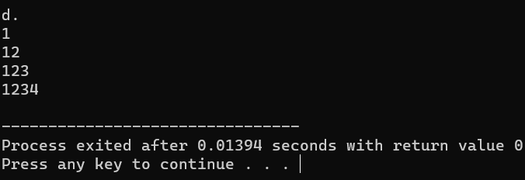

Pattern E

#include <stdio.h>

int main() {

printf("e.\n");

for (int i = 1; i <= 5; i++) {

for (int j = 1; j <= i; j++) {

printf("*");

}

printf("\n");

}

return 0;

}

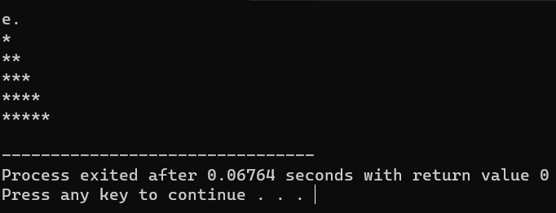

**WORKSHEET WEEK 6**

Q.

Ans.

# include <stdio.h>

int main ()

{

int a;

printf("enter the no of the elements of the array:- ");

scanf("%d",&a);

int n[a];

for(int i=0;i<a;i++)

{

printf("enter the %d element of the array:- ",i+1);

scanf("%d",&n[i]);

}

int k;

printf("enter the element which u want to delete:- ");

scanf("%d",&k);

int g;

printf("enter the element insert behalf of delete element:- ");

scanf("%d",&g);

for(int i=0;i<a;i++)

{

if(n[i]==k)

{ n[i]=g;

}

else

{

printf("not found!");

break;

}

}

for(int i=0;i<a;i++)

{

printf("\n%d ",n[i]);

}

return 0;

}

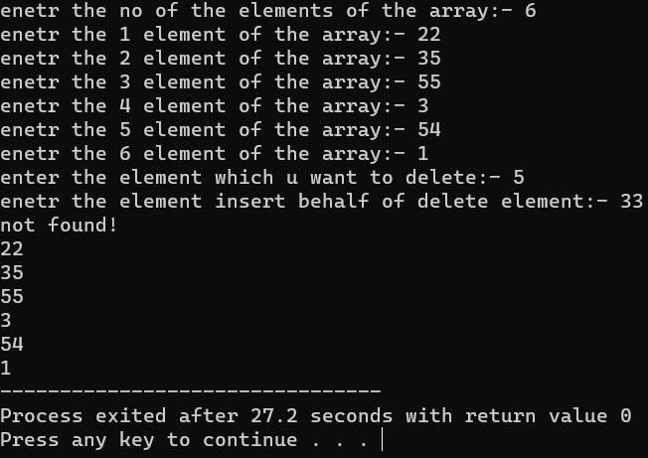

Q2. Write the program to print the biggest and smallest element in an array.

#include <stdio.h>

int main() {

int size;

printf("Enter the size of the array: ");

scanf("%d", &size);

if (size <= 0) {

printf("Invalid array size. Exiting...\n");

return 1;

}

int arr[size];

printf("Enter %d elements:\n", size);

for (int i = 0; i < size; i++) {

printf("Element %d: ", i + 1);

scanf("%d", &arr[i]);

}

int largest = arr[0];

int smallest = arr[0];

for (int i = 1; i < size; i++) {

if (arr[i] > largest) {

largest = arr[i];

}

if (arr[i] < smallest) {

smallest = arr[i];

}

}

printf("The largest element is: %d\n", largest);

printf("The smallest element is: %d\n", smallest);

return 0;

}

Q3. Write the program to print the sum and average of an array.

#include <stdio.h>

int main() {

int size;

printf("Enter the size of the array: ");

scanf("%d", &size);

if (size <= 0) {

printf("Invalid array size. Exiting...\n");

return 1;

}

int arr[size];

printf("Enter %d elements:\n", size);

for (int i = 0; i < size; i++) {

printf("Element %d: ", i + 1);

scanf("%d", &arr[i]);

}

int sum = 0;

for (int i = 0; i < size; i++) {

sum += arr[i];

}

float average = (float)sum / size;

printf("The sum of the elements is: %d\n", sum);

printf("The average of the elements is: %.2f\n", average);

return 0;

}

Q4. Write the program to sort an array using bubble sort.

#include <stdio.h>

void swap(int *a, int *b) {

int temp = *a;

*a = *b;

*b = temp;

}

void bubbleSort(int arr[], int size) {

for (int i = 0; i < size - 1; i++) {

for (int j = 0; j < size - i - 1; j++) {

if (arr[j] > arr[j + 1]) {

swap(&arr[j], &arr[j + 1]);

}

}

}

}

int main() {

int size;

printf("Enter the size of the array: ");

scanf("%d", &size);

if (size <= 0) {

printf("Invalid array size. Exiting...\n");

return 1;

}

int arr[size];

printf("Enter %d elements:\n", size);

for (int i = 0; i < size; i++) {

printf("Element %d: ", i + 1);

scanf("%d", &arr[i]);

}

bubbleSort(arr, size);

printf("\nSorted array using Bubble Sort:\n");

for (int i = 0; i < size; i++) {

printf("%d ", arr[i]);

}

printf("\n");

return 0;

}

Q5. Write the program to search an element using linear search as well as binary search.

#include <stdio.h>

int linearSearch(int arr[], int size, int key) {

for (int i = 0; i < size; i++) {

if (arr[i] == key) {

return 0;

}

}

return -1;

}

int binarySearch(int arr[], int size, int key) {

int low = 0, high = size - 1;

while (low <= high) {

int mid = low + (high - low) / 2;

if (arr[mid] == key) {

return mid;

} else if (arr[mid] < key) {

low = mid + 1;

} else {

high = mid - 1;

}

}

return -1;

}

int main() {

int size, key;

printf("Enter the size of the array: ");

scanf("%d", &size);

if (size <= 0) {

printf("Invalid array size. Exiting...\n");

return 1;

}

int arr[size];

printf("Enter %d sorted elements:\n", size);

for (int i = 0; i < size; i++) {

printf("Element %d: ", i + 1);

scanf("%d", &arr[i]);

}

printf("Enter the element to search: ");

scanf("%d", &key);

int linearIndex = linearSearch(arr, size, key);

if (linearIndex != -1) {

printf("Linear Search: Element found at index %d\n", linearIndex);

} else {

printf("Linear Search: Element not found\n");

}

int binaryIndex = binarySearch(arr, size, key);

if (binaryIndex != -1) {

printf("Binary Search: Element found at index %d\n", binaryIndex);

} else {

printf("Binary Search: Element not found\n");

}

return 0;

}

Q6. Take an array of 20 integer inputs from user and print the following: a. number of positive numbers b. number of negative numbers c. number of odd numbers d. number of even numbers e. number of 0.

#include <stdio.h>

int main() {

const int size = 20;

int numbers[size];

printf("Enter %d integer numbers:\n", size);

for (int i = 0; i < size; i++) {

printf("Element %d: ", i + 1);

scanf("%d", &numbers[i]);

}

int positiveCount = 0, negativeCount = 0, oddCount = 0, evenCount = 0, zeroCount = 0;

for (int i = 0; i < size; i++) {

if (numbers[i] > 0) {

positiveCount++;

} else if (numbers[i] < 0) {

negativeCount++;

}

if (numbers[i] % 2 == 0) {

evenCount++;

} else {

oddCount++;

}

if (numbers[i] == 0) {

zeroCount++;

}

}

printf("\nStatistics:\n");

printf("a. Number of positive numbers: %d\n", positiveCount);

printf("b. Number of negative numbers: %d\n", negativeCount);

printf("c. Number of odd numbers: %d\n", oddCount);

printf("d. Number of even numbers: %d\n", evenCount);

printf("e. Number of zeros: %d\n", zeroCount);

return 0;

}

Q7. Take an array of 10 elements. Split it into middle and store the elements in two different arrays.

#include <stdio.h>

int main() {

const int size = 10;

int originalArray[size];

int firstArray[size / 2], secondArray[size / 2];

printf("Enter %d integer numbers:\n", size);

for (int i = 0; i < size; i++) {

printf("Element %d: ", i + 1);

scanf("%d", &originalArray[i]);

}

for (int i = 0; i < size / 2; i++) {

firstArray[i] = originalArray[i];

secondArray[i] = originalArray[size / 2 + i];

}

printf("\nOriginal Array:\n");

for (int i = 0; i < size; i++) {

printf("%d ", originalArray[i]);

}

printf("\n\nSplit Arrays:\n");

printf("First Array:\n");

for (int i = 0; i < size / 2; i++) {

printf("%d ", firstArray[i]);

}

printf("\nSecond Array:\n");

for (int i = 0; i < size / 2; i++) {

printf("%d ", secondArray[i]);

}

return 0;

}

Q8. Write the program to count frequency of each element in an array.

#include <stdio.h>

int main() {

const int size = 10;

int arr[size];

printf("Enter %d integer numbers:\n", size);

for (int i = 0; i < size; i++) {

printf("Element %d: ", i + 1);

scanf("%d", &arr[i]);

}

int frequency[size];

for (int i = 0; i < size; i++) {

frequency[i] = -1;

}

for (int i = 0; i < size; i++) {

int count = 1;

for (int j = i + 1; j < size; j++) {

if (arr[i] == arr[j]) {

count++;

frequency[j] = 0;

}

}

if (frequency[i] != 0) {

frequency[i] = count;

}

}

printf("\nFrequency of each element:\n");

for (int i = 0; i < size; i++) {

if (frequency[i] != 0) {

printf("%d occurs %d times\n", arr[i], frequency[i]);

}

}

return 0;

}

**WORKSHEET WEEK 7**

Q1. Write the program to print row major and column major matrix.

#include <stdio.h>

int main() {

int rows, cols;

printf("Enter the number of rows: ");

scanf("%d", &rows);

printf("Enter the number of columns: ");

scanf("%d", &cols);

if (rows <= 0 || cols <= 0) {

printf("Invalid matrix size. Exiting...\n");

return 1;

}

int matrix[rows][cols];

printf("Enter the matrix elements:\n");

for (int i = 0; i < rows; i++) {

for (int j = 0; j < cols; j++) {

printf("Element at (%d, %d): ", i + 1, j + 1);

scanf("%d", &matrix[i][j]);

}

}

printf("\nRow-Major Order:\n");

for (int i = 0; i < rows; i++) {

for (int j = 0; j < cols; j++) {

printf("%d ", matrix[i][j]);

}

printf("\n");

}

printf("\nColumn-Major Order:\n");

for (int j = 0; j < cols; j++) {

for (int i = 0; i < rows; i++) {

printf("%d ", matrix[i][j]);

}

printf("\n");

}

return 0;

}

Q2. Write the program to print sum of a whole matrix.

#include <stdio.h>

int main() {

int rows, cols;

printf("Enter the number of rows: ");

scanf("%d", &rows);

printf("Enter the number of columns: ");

scanf("%d", &cols);

if (rows <= 0 || cols <= 0) {

printf("Invalid matrix size. Exiting...\n");

return 1;

}

int matrix[rows][cols];

printf("Enter the matrix elements:\n");

for (int i = 0; i < rows; i++) {

for (int j = 0; j < cols; j++) {

printf("Element at (%d, %d): ", i + 1, j + 1);

scanf("%d", &matrix[i][j]);

}

}

int sum = 0;

for (int i = 0; i < rows; i++) {

for (int j = 0; j < cols; j++) {

sum += matrix[i][j];

}

}

printf("\nSum of the matrix: %d\n", sum);

return 0;

}

Q3. Write a program to add and multiply two 3x3 matrices. You can use 2D array to create a matrix.

#include <stdio.h>

void addMatrices(int mat1[3][3], int mat2[3][3], int result[3][3]) {

for (int i = 0; i < 3; i++) {

for (int j = 0; j < 3; j++) {

result[i][j] = mat1[i][j] + mat2[i][j];

}

}

}

void multiplyMatrices(int mat1[3][3], int mat2[3][3], int result[3][3]) {

for (int i = 0; i < 3; i++) {

for (int j = 0; j < 3; j++) {

result[i][j] = 0;

for (int k = 0; k < 3; k++) {

result[i][j] += mat1[i][k] * mat2[k][j];

}

}

}

}

void printMatrix(int mat[3][3]) {

for (int i = 0; i < 3; i++) {

for (int j = 0; j < 3; j++) {

printf("%d ", mat[i][j]);

}

printf("\n");

}

}

int main() {

int matrix1[3][3], matrix2[3][3], resultAddition[3][3], resultMultiplication[3][3];

printf("Enter elements for the first matrix (3x3):\n");

for (int i = 0; i < 3; i++) {

for (int j = 0; j < 3; j++) {

printf("Element at (%d, %d): ", i + 1, j + 1);

scanf("%d", &matrix1[i][j]);

}

}

printf("\nEnter elements for the second matrix (3x3):\n");

for (int i = 0; i < 3; i++) {

for (int j = 0; j < 3; j++) {

printf("Element at (%d, %d): ", i + 1, j + 1);

scanf("%d", &matrix2[i][j]);

}

}

addMatrices(matrix1, matrix2, resultAddition);

multiplyMatrices(matrix1, matrix2, resultMultiplication);

printf("\nMatrix Addition:\n");

printMatrix(resultAddition);

printf("\nMatrix Multiplication:\n");

printMatrix(resultMultiplication);

return 0;

}

Q4. Write the program to print sum of all diagonal elements, upper triangular matrix and lower triangular matrix.

#include <stdio.h>

int main() {

int size;

printf("Enter the size of the square matrix: ");

scanf("%d", &size);

if (size <= 0) {

printf("Invalid matrix size. Exiting...\n");

return 1;

}

int matrix[size][size];

printf("Enter the matrix elements (%dx%d):\n", size, size);

for (int i = 0; i < size; i++) {

for (int j = 0; j < size; j++) {

printf("Element at (%d, %d): ", i + 1, j + 1);

scanf("%d", &matrix[i][j]);

}

}

int diagonalSum = 0;

for (int i = 0; i < size; i++) {

diagonalSum += matrix[i][i];

}

int upperTriangularSum = 0;

for (int i = 0; i < size; i++) {

for (int j = i + 1; j < size; j++) {

upperTriangularSum += matrix[i][j];

}

}

int lowerTriangularSum = 0;

for (int i = 0; i < size; i++) {

for (int j = 0; j < i; j++) {

lowerTriangularSum += matrix[i][j];

}

}

printf("\nSum of Diagonal Elements: %d\n", diagonalSum);

printf("Sum of Upper Triangular Matrix: %d\n", upperTriangularSum);

printf("Sum of Lower Triangular Matrix: %d\n", lowerTriangularSum);

return 0;

}

Q5. Write the program to find the frequency of odd and even elements in matrix.

#include <stdio.h>

int main() {

int rows, cols;

printf("Enter the number of rows: ");

scanf("%d", &rows);

printf("Enter the number of columns: ");

scanf("%d", &cols);

if (rows <= 0 || cols <= 0) {

printf("Invalid matrix size. Exiting...\n");

return 1;

}

int matrix[rows][cols];

printf("Enter the matrix elements:\n");

for (int i = 0; i < rows; i++) {

for (int j = 0; j < cols; j++) {

printf("Element at (%d, %d): ", i + 1, j + 1);

scanf("%d", &matrix[i][j]);

}

}

int evenCount = 0, oddCount = 0;

for (int i = 0; i < rows; i++) {

for (int j = 0; j < cols; j++) {

if (matrix[i][j] % 2 == 0) {

evenCount++;

} else {

oddCount++;

}

}

}

printf("\nFrequency of even elements: %d\n", evenCount);

printf("Frequency of odd elements: %d\n", oddCount);

return 0;

}

Q6. Write the program to find sum of each row and sum of each column of matrix.

#include <stdio.h>

int main() {

int rows, cols;

printf("Enter the number of rows: ");

scanf("%d", &rows);

printf("Enter the number of columns: ");

scanf("%d", &cols);

if (rows <= 0 || cols <= 0) {

printf("Invalid matrix size. Exiting...\n");

return 1;

}

int matrix[rows][cols];

printf("Enter the matrix elements:\n");

for (int i = 0; i < rows; i++) {

for (int j = 0; j < cols; j++) {

printf("Element at (%d, %d): ", i + 1, j + 1);

scanf("%d", &matrix[i][j]);

}

}

printf("\nSum of each row:\n");

for (int i = 0; i < rows; i++) {

int rowSum = 0;

for (int j = 0; j < cols; j++) {

rowSum += matrix[i][j];

}

printf("Row %d: %d\n", i + 1, rowSum);

}

printf("\nSum of each column:\n");

for (int j = 0; j < cols; j++) {

int colSum = 0;

for (int i = 0; i < rows; i++) {

colSum += matrix[i][j];

}

printf("Column %d: %d\n", j + 1, colSum);

}

return 0;

}

Q7. Initialize a 2D array of 3*3 matrix.

#include <stdio.h>

int main() {

int matrix[3][3] = {

{1, 2, 3},

{4, 5, 6},

{7, 8, 9}

};

printf("Initialized 3x3 Matrix:\n");

for (int i = 0; i < 3; i++) {

for (int j = 0; j < 3; j++) {

printf("%d ", matrix[i][j]);

}

printf("\n");

}

return 0;

}

Q8. A square matrix, one having the same number of rows and columns, is called a diagonal matrix if it’s only non-zero elements are on the diagonal from upper left to lower right. It is called upper triangular matrix if all elements bellow the diagonal are zeroes, and lower triangular matrix, if all the elements above the diagonal are zeroes. Write a program that reads a matrix and determines if it is one of the above mentioned three special matrices.

#include <stdio.h>

int isDiagonalMatrix(int matrix[3][3], int size) {

for (int i = 0; i < size; i++) {

for (int j = 0; j < size; j++) {

if (i != j && matrix[i][j] != 0) {

return 0;

}

}

}

return 1;

}

int isUpperTriangularMatrix(int matrix[3][3], int size) {

for (int i = 0; i < size; i++) {

for (int j = 0; j < i; j++) {

if (matrix[i][j] != 0) {

return 0;

}

}

}

return 1;

}

int isLowerTriangularMatrix(int matrix[3][3], int size) {

for (int i = 0; i < size; i++) {

for (int j = i + 1; j < size; j++) {

if (matrix[i][j] != 0) {

return 0;

}

}

}

return 1;

}

int main() {

int size;

printf("Enter the size of the square matrix: ");

scanf("%d", &size);

if (size <= 0) {

printf("Invalid matrix size. Exiting...\n");

return 1;

}

int matrix[3][3];

printf("Enter the matrix elements (%dx%d):\n", size, size);

for (int i = 0; i < size; i++) {

for (int j = 0; j < size; j++) {

printf("Element at (%d, %d): ", i + 1, j + 1);

scanf("%d", &matrix[i][j]);

}

}

if (isDiagonalMatrix(matrix, size)) {

printf("The matrix is a diagonal matrix.\n");

} else if (isUpperTriangularMatrix(matrix, size)) {

printf("The matrix is an upper triangular matrix.\n");

} else if (isLowerTriangularMatrix(matrix, size)) {

printf("The matrix is a lower triangular matrix.\n");

} else {

printf("The matrix is not one of the specified special matrices.\n");

}

return 0;

}

Q9. Write the program to check whether the matrix is sparse matrix or not.

#include <stdio.h>

#define MAX_SIZE 10

int isSparseMatrix(int matrix[MAX_SIZE][MAX_SIZE], int rows, int cols) {

int zeroCount = 0;

for (int i = 0; i < rows; i++) {

for (int j = 0; j < cols; j++) {

if (matrix[i][j] == 0) {

zeroCount++;

}

}

}

double threshold = 0.6;

double zeroPercentage = (double)zeroCount / (rows * cols);

if (zeroPercentage > threshold) {

return 1; // Sparse matrix

} else {

return 0;

}

}

int main() {

int rows, cols;

printf("Enter the number of rows: ");

scanf("%d", &rows);

printf("Enter the number of columns: ");

scanf("%d", &cols);

if (rows <= 0 || cols <= 0 || rows > MAX_SIZE || cols > MAX_SIZE) {

printf("Invalid matrix size. Exiting...\n");

return 1;

}

int matrix[MAX_SIZE][MAX_SIZE];

printf("Enter the matrix elements (%dx%d):\n", rows, cols);

for (int i = 0; i < rows; i++) {

for (int j = 0; j < cols; j++) {

printf("Element at (%d, %d): ", i + 1, j + 1);

scanf("%d", &matrix[i][j]);

}

}

if (isSparseMatrix(matrix, rows, cols)) {

printf("The matrix is a sparse matrix.\n");

} else {

printf("The matrix is not a sparse matrix.\n");

}

return 0;

}

**WORKSHEET WEEK 8**

Q1. Write a C program to create, initialize and use pointers.

#include <stdio.h>

int main() {

int number = 42;

float floatNumber = 3.14;

char character = 'A';

int *intPointer;

float *floatPointer;

char *charPointer;

intPointer = &number;

floatPointer = &floatNumber;

charPointer = &character;

printf("Original values:\n");

printf("Number: %d\n", number);

printf("Float Number: %.2f\n", floatNumber);

printf("Character: %c\n\n", character);

*intPointer = 100;

*floatPointer = 2.718;

*charPointer = 'B';

printf("Modified values using pointers:\n");

printf("Number: %d\n", number);

printf("Float Number: %.2f\n", floatNumber);

printf("Character: %c\n\n", character);

int anotherNumber = 10;

int *resultPointer = &number;

*resultPointer += anotherNumber;

printf("Result of adding %d to the original number using pointers: %d\n", anotherNumber, *resultPointer);

return 0;

}

Q2. Write a C program to add two numbers using pointers.

#include <stdio.h>

int main() {

int num1, num2, sum;

int *ptr1, *ptr2;

ptr1 = &num1;

ptr2 = &num2;

printf("Enter the first number: ");

scanf("%d", ptr1);

printf("Enter the second number: ");

scanf("%d", ptr2);

sum = *ptr1 + *ptr2;

printf("Sum of %d and %d is: %d\n", *ptr1, *ptr2, sum);

return 0;

}

Q3. Write a C program to swap two numbers using pointers.

#include <stdio.h>

void swap(int *num1, int *num2) {

int temp = *num1;

*num1 = *num2;

*num2 = temp;

}

int main() {

int num1, num2;

printf("Enter the first number: ");

scanf("%d", &num1);

printf("Enter the second number: ");

scanf("%d", &num2);

printf("\nOriginal values:\n");

printf("First number: %d\n", num1);

printf("Second number: %d\n", num2);

swap(&num1, &num2);

printf("\nSwapped values:\n");

printf("First number: %d\n", num1);

printf("Second number: %d\n", num2);

return 0;

}

Q. 4 Write a C program to input and print array elements using pointer.

#include <stdio.h>

int main() {

int size;

printf("Enter the size of the array: ");

scanf("%d", &size);

if (size <= 0) {

printf("Invalid array size. Exiting...\n");

return 1;

}

int arr[size];

printf("Enter %d elements for the array:\n", size);

for (int i = 0; i < size; i++) {

printf("Element %d: ", i + 1);

scanf("%d", &(*(arr + i)));

}

printf("\nArray elements using pointers:\n");

for (int i = 0; i < size; i++) {

printf("%d ", *(arr + i));

}

return 0;

}

Q. 5 Write a C program to copy one array to another using pointer.

#include <stdio.h>

void copyArray(int *source, int *destination, int size) {

for (int i = 0; i < size; i++) {

*(destination + i) = *(source + i);

}

}

int main() {

int size;

printf("Enter the size of the array: ");

scanf("%d", &size);

if (size <= 0) {

printf("Invalid array size. Exiting...\n");

return 1;

}

int sourceArray[size];

int destinationArray[size];

printf("Enter %d elements for the source array:\n", size);

for (int i = 0; i < size; i++) {

printf("Element %d: ", i + 1);

scanf("%d", &(*(sourceArray + i)));

}

copyArray(sourceArray, destinationArray, size);

printf("\nSource Array elements:\n");

for (int i = 0; i < size; i++) {

printf("%d ", *(sourceArray + i));

}

printf("\nDestination Array elements (copied from source):\n");

for (int i = 0; i < size; i++) {

printf("%d ", *(destinationArray + i));

}

return 0;

}

Q. 6 Write a C program to swap two arrays using pointers.

#include <stdio.h>

void swapArrays(int *arr1, int *arr2, int size) {

for (int i = 0; i < size; i++) {

int temp = *(arr1 + i);

*(arr1 + i) = *(arr2 + i);

*(arr2 + i) = temp;

}

}

void printArray(int *arr, int size) {

for (int i = 0; i < size; i++) {

printf("%d ", *(arr + i));

}

printf("\n");

}

int main() {

int size;

printf("Enter the size of the arrays: ");

scanf("%d", &size);

if (size <= 0) {

printf("Invalid array size. Exiting...\n");

return 1;

}

int array1[size], array2[size];

printf("Enter %d elements for the first array:\n", size);

for (int i = 0; i < size; i++) {

printf("Element %d: ", i + 1);

scanf("%d", &(*(array1 + i)));

}

printf("\nEnter %d elements for the second array:\n", size);

for (int i = 0; i < size; i++) {

printf("Element %d: ", i + 1);

scanf("%d", &(*(array2 + i)));

}

printf("\nOriginal Arrays:\n");

printf("Array 1: ");

printArray(array1, size);

printf("Array 2: ");

printArray(array2, size);

swapArrays(array1, array2, size);

printf("\nSwapped Arrays:\n");

printf("Array 1: ");

printArray(array1, size);

printf("Array 2: ");

printArray(array2, size);

return 0;

}

Q. 7 Write a C program to reverse an array using pointers.

#include <stdio.h>

void reverseArray(int *arr, int size) {

int *start = arr;

int *end = arr + size - 1;

while (start < end) {

int temp = *start;

*start = *end;

*end = temp;

start++;

end--;

}

}

void printArray(int *arr, int size) {

for (int i = 0; i < size; i++) {

printf("%d ", *(arr + i));

}

printf("\n");

}

int main() {

int size;

printf("Enter the size of the array: ");

scanf("%d", &size);

if (size <= 0) {

printf("Invalid array size. Exiting...\n");

return 1;

}

int array[size];

printf("Enter %d elements for the array:\n", size);

for (int i = 0; i < size; i++) {

printf("Element %d: ", i + 1);

scanf("%d", &(*(array + i)));

}

printf("\nOriginal Array:\n");

printArray(array, size);

reverseArray(array, size);

printf("\nReversed Array:\n");

printArray(array, size);

return 0;

}

Q. 8 Write a C program to add two matrix using pointers.

#include <stdio.h>

#define MAX_SIZE 10

void addMatrices(int *matrix1, int *matrix2, int *result, int rows, int cols) {

for (int i = 0; i < rows; i++) {

for (int j = 0; j < cols; j++) {

*(result + i * cols + j) = *(matrix1 + i * cols + j) + *(matrix2 + i * cols + j);

}

}

}

void printMatrix(int *matrix, int rows, int cols) {

for (int i = 0; i < rows; i++) {

for (int j = 0; j < cols; j++) {

printf("%d ", *(matrix + i * cols + j));

}

printf("\n");

}

}

int main() {

int rows, cols;

printf("Enter the number of rows: ");

scanf("%d", &rows);

printf("Enter the number of columns: ");

scanf("%d", &cols);

if (rows <= 0 || cols <= 0 || rows > MAX_SIZE || cols > MAX_SIZE) {

printf("Invalid matrix size. Exiting...\n");

return 1;

}

int matrix1[MAX_SIZE][MAX_SIZE], matrix2[MAX_SIZE][MAX_SIZE], result[MAX_SIZE][MAX_SIZE];

printf("Enter elements for the first matrix (%dx%d):\n", rows, cols);

for (int i = 0; i < rows; i++) {

for (int j = 0; j < cols; j++) {

printf("Element at (%d, %d): ", i + 1, j + 1);

scanf("%d", &(*(matrix1 + i * cols + j)));

}

}

printf("\nEnter elements for the second matrix (%dx%d):\n", rows, cols);

for (int i = 0; i < rows; i++) {

for (int j = 0; j < cols; j++) {

printf("Element at (%d, %d): ", i + 1, j + 1);

scanf("%d", &(*(matrix2 + i * cols + j)));

}

}

addMatrices((int *)matrix1, (int *)matrix2, (int *)result, rows, cols);

printf("\nOriginal Matrices:\n");

printf("Matrix 1:\n");

printMatrix((int *)matrix1, rows, cols);

printf("Matrix 2:\n");

printMatrix((int *)matrix2, rows, cols);

printf("\nResult Matrix (Sum of Matrix 1 and Matrix 2):\n");

printMatrix((int *)result, rows, cols);

return 0;

}

Q. 9 Write a C program to multiply two matrix using pointers.

#include <stdio.h>

#define MAX_SIZE 10

void multiplyMatrices(int *matrix1, int *matrix2, int *result, int rows1, int cols1, int cols2) {

for (int i = 0; i < rows1; i++) {

for (int j = 0; j < cols2; j++) {

*(result + i * cols2 + j) = 0;

for (int k = 0; k < cols1; k++) {

*(result + i * cols2 + j) += *(matrix1 + i * cols1 + k) * *(matrix2 + k * cols2 + j);

}

}

}

}

void printMatrix(int *matrix, int rows, int cols) {

for (int i = 0; i < rows; i++) {

for (int j = 0; j < cols; j++) {

printf("%d ", *(matrix + i * cols + j));

}

printf("\n");

}

}

int main() {

int rows1, cols1, rows2, cols2;

printf("Enter the number of rows for the first matrix: ");

scanf("%d", &rows1);

printf("Enter the number of columns for the first matrix: ");

scanf("%d", &cols1);

printf("\nEnter the number of rows for the second matrix: ");

scanf("%d", &rows2);

printf("Enter the number of columns for the second matrix: ");

scanf("%d", &cols2);

if (cols1 != rows2) {

printf("Invalid matrix dimensions for multiplication. Exiting...\n");

return 1;

}

if (rows1 <= 0 || cols1 <= 0 || rows2 <= 0 || cols2 <= 0 ||

rows1 > MAX_SIZE || cols1 > MAX_SIZE || rows2 > MAX_SIZE || cols2 > MAX_SIZE) {

printf("Invalid matrix size. Exiting...\n");

return 1;

}

int matrix1[MAX_SIZE][MAX_SIZE], matrix2[MAX_SIZE][MAX_SIZE], result[MAX_SIZE][MAX_SIZE];

printf("\nEnter elements for the first matrix (%dx%d):\n", rows1, cols1);

for (int i = 0; i < rows1; i++) {

for (int j = 0; j < cols1; j++) {

printf("Element at (%d, %d): ", i + 1, j + 1);

scanf("%d", &(*(matrix1 + i * cols1 + j)));

}

}

/

printf("\nEnter elements for the second matrix (%dx%d):\n", rows2, cols2);

for (int i = 0; i < rows2; i++) {

for (int j = 0; j < cols2; j++) {

printf("Element at (%d, %d): ", i + 1, j + 1);

scanf("%d", &(*(matrix2 + i * cols2 + j)));

}

}

multiplyMatrices((int *)matrix1, (int *)matrix2, (int *)result, rows1, cols1, cols2);

printf("\nOriginal Matrices:\n");

printf("Matrix 1:\n");

printMatrix((int *)matrix1, rows1, cols1);

printf("Matrix 2:\n");

printMatrix((int *)matrix2, rows2, cols2);

printf("\nResult Matrix (Product of Matrix 1 and Matrix 2):\n");

printMatrix((int *)result, rows1, cols2);

return 0;

}

**WORKSHEET WEEK 9**

Q. 1 Write a C program to Search string.

#include <stdio.h>

#include <string.h>

int main() {

char s1[] = "Beauty is in the eye of the beholder";

char s2[] = "the";

int n = 0;

int m = 0;

int times = 0;

int len = strlen(s2);

while(s1[n] != '\0') {

if(s1[n] == s2[m]) {

while(s1[n] == s2[m] && s1[n] !='\0') {

n++;

m++;

}

if(m == len && (s1[n] == ' ' || s1[n] == '\0')) {

times++;

}

} else {

while(s1[n] != ' ') {

n++;

if(s1[n] == '\0')

break;

}

}

n++;

m=0;

}

if(times > 0) {

printf("'%s' appears %d time(s)\n", s2, times);

} else {

printf("'%s' does not appear in the sentence.\n", s2);

}

return 0;

}

Q. 2 Write a C program to Reverse words in string.

#include <stdio.h>

#include <string.h>

#define MAX_SIZE 100

int main()

{

char str[100], reverse[100];

int len, i, index, wordStart, wordEnd;

printf("Enter any string: ");

gets(str);

len = strlen(str);

index = 0;

wordStart = len - 1;

wordEnd = len - 1;

while(wordStart > 0)

{

if(str[wordStart] == ' ')

{

i = wordStart + 1;

while(i <= wordEnd)

{

reverse[index] = str[i];

i++;

index++;

}

reverse[index++] = ' ';

wordEnd = wordStart - 1;

}

wordStart--;

}

for(i=0; i<=wordEnd; i++)

{

reverse[index] = str[i];

index++;

}

reverse[index] = '\0';

printf("Original string \n%s\n\n", str);

printf("Reverse ordered words \n%s", reverse);

return 0;

}

Q. 3 Write a C program to count vowels, consonants, etc.

#include <stdio.h>

int main() {

char line[150];

int vowels, consonant, digit, space;

vowels = consonant = digit = space = 0;

printf("Enter a line of string: ");

fgets(line, sizeof(line), stdin);

for (int i = 0; line[i] != '\0'; ++i) {

line[i] = tolower(line[i]);

if (line[i] == 'a' || line[i] == 'e' || line[i] == 'i' ||

line[i] == 'o' || line[i] == 'u') {

++vowels;

}

else if ((line[i] >= 'a' && line[i] <= 'z')) {

++consonant;

}

else if (line[i] >= '0' && line[i] <= '9') {

++digit;

}

else if (line[i] == ' ') {

++space;

}

}

printf("Vowels: %d", vowels);

printf("\nConsonants: %d", consonant);

printf("\nDigits: %d", digit);

printf("\nWhite spaces: %d", space);

return 0;

}

Q. 4 Create a program to separate characters in a given string?

#include <stdio.h>

#include <stdlib.h>

void main()

{

char str[100];

int l= 0;

printf("\n\separate the individual characters from a string :\n");

printf("------------------------------------------------------\n");

printf("Input the string : ");

fgets(str, sizeof str, stdin);

printf("The characters of the string are : \n");

while(str[l]!='\0')

{

printf("%c ", str[l]);

l++;

}

printf("\n");

}

Q. 5 Write a program to take two strings from user and concatenate them also add a space between them using strcat() function.

Sample input:

JAI

GLA

Sample output: JAI GLA

#include <stdio.h>

#include <string.h>

int main()

{

char a[100], b[100];

printf("Enter the first string\n");

gets(a);

printf("Enter the second string\n");

gets(b);

strcat(a,b);

printf("String obtained on concatenation is %s\n",a);

return 0;

}

Q. 6 Write a C program to take a string from user and make it toggle its case i.e. lower case to upper case and upper case to lower case.

Sample Input: HElLo wOrlD

Sample output: heLlO WoRLd

#include <stdio.h>

void toggleChars(char str[])

{

for (int i = 0; str[i] != '\0'; i++) {

if (str[i] >= 'A' && str[i] <= 'Z')

str[i] = str[i] + 'a' - 'A';

else if (str[i] >= 'a' && str[i] <= 'z')

str[i] = str[i] + 'A' - 'a';

}

}

int main()

{

char str[] = "GeKf@rGeek$";

toggleChars(str);

printf("String after toggle \n");

printf("%s\n", str);

return 0;

}

Q. 7 Write a C program to take two strings as input from user and check they are identical or not without using string functions.

Sample input:

Jai Gla

Jai Gla

Sample output: Identical

#include <stdio.h>

#include <string.h>

int main()

{

char Str1[100], Str2[100];

int result, i;

printf("\n Please Enter the First String : ");

gets(Str1);

printf("\n Please Enter the Second String : ");

gets(Str2);

for(i = 0; Str1[i] == Str2[i] && Str1[i] == '\0'; i++);

if(Str1[i] < Str2[i])

{

printf("\n str1 is Less than str2");

}

else if(Str1[i] > Str2[i])

{

printf("\n str2 is Less than str1");

}

else

{

printf("\n str1 is Equal to str2");

}

return 0;

}

Q. 8 Write a C program to take a list of a student’s names from user by asking number of students and sort them alphabetical order.

Sample Input:

Bhisham

Jayant

Abhishek

Dhruv

Sample Output:

Abhishek

Bhisham

Dhruv

Jayant

#include <stdio.h>

#include <stdlib.h>

#include <string.h>

int main() {

int numStudents;

printf("Enter the number of students: ");

scanf("%d", &numStudents);

if (numStudents <= 0) {

printf("Invalid number of students. Exiting...\n");

return 1;

}

char **studentNames = (char **)malloc(numStudents * sizeof(char *));

for (int i = 0; i < numStudents; i++) {

printf("Enter the name of student %d: ", i + 1);

studentNames[i] = (char *)malloc(100 * sizeof(char));

scanf("%s", studentNames[i]);

}

for (int i = 0; i < numStudents - 1; i++) {

for (int j = i + 1; j < numStudents; j++) {

if (strcmp(studentNames[i], studentNames[j]) > 0) {

char *temp = studentNames[i];

studentNames[i] = studentNames[j];

studentNames[j] = temp;

}

}

}

printf("\nSorted names in alphabetical order:\n");

for (int i = 0; i < numStudents; i++) {

printf("%d. %s\n", i + 1, studentNames[i]);

}

for (int i = 0; i < numStudents; i++) {

free(studentNames[i]);

}

free(studentNames);

return 0;

}

**WEEK WORKSHEET 10**

Q. 1 Write a C program to find length of string using pointers.

#include <stdio.h>

int main() {

char str[100], * ptr;

int count;

printf("Enter any string: ");

gets(str);

ptr = str;

count = 0;

while ( *ptr != '\0') {

count++;

ptr++;

}

printf("The length of the string is: %d", count);

return 0;

}

Q. 2 Write a C program to copy one string to another using pointer.

#include<stdio.h>

void copy_string(char*, char*);

main()

{

char source[100], target[100];

printf("Enter source string\n");

gets(source);

copy_string(target, source);

printf("Target string is \"%s\"\n", target);

return 0;

}

void copy_string(char *target, char *source)

{

while(*source)

{

*target = *source;

source++;

target++;

}

*target = '\0';

}

Q. 3 Write a C program to concatenate two strings using pointers.

#include <stdio.h>

void concatenate(char *str1, char *str2) {

while (*str1) {

str1++;

}

while (*str2) {

*str1 = *str2;

str1++;

str2++;

}

*str1 = '\0';

}

int main() {

char string1[100], string2[50];

printf("Enter the first string:\n");

gets(string1);

printf("Enter the second string:\n");

gets(string2);

concatenate(string1, string2);

printf("Concatenated string: %s\n", string1);

return 0;

}

Q. 4 Write a C program to compare two strings using pointers.

#include <iostream>

using namespace std;

int main()

{

char string1[50],string2[50],*str1,*str2;

int i,equal = 0;

printf("Enter The First String: ");

scanf("%s",string1);

printf("Enter The Second String: ");

scanf("%s",string2);

str1 = string1;

str2 = string2;

while(*str1 == *str2)

{

if ( *str1 == '\0' || *str2 == '\0' )

break;

str1++;

str2++;

}

if( *str1 == '\0' && *str2 == '\0' )

printf("\n\nBoth Strings Are Equal.");

else

printf("\n\nBoth Strings Are Not Equal.");

}

Q. 5 WAP to find largest among three numbers using pointer

Q. 6 WAP to find largest among three numbers using pointer.

#include<stdio.h>

int main()

{

int a,b,c,*pa, *pb, *pc;

printf("Enter three numbers:\n");

scanf("%d%d%d", &a,&b,&c);

pa= &a;

pb= &b;

pc= &c;

if(*pa > *pb && *pa > *pc)

{

printf("Largest is: %d", *pa);

}

else if(*pb > *pc && *pb > *pc)

{

printf("Largest is : %d", *pb);

}

else

{

printf("Largest = %d", *pc);

}

return 0;

}

Q. 7 WAP to find factorial of a number using pointer.

#include<stdio.h>

void findFactorial(int,int *);

int main(){

int i,factorial,n;

printf("Enter a number: ");

scanf("%d",&n);

findFactorial(n,&factorial);

printf("Factorial of %d is: %d",n,*factorial);

return 0;

}

void findFactorial(int n,int *factorial){

int i;

*factorial =1;

for(i=1;i<=n;i++)

*factorial=*factorial*i;

}

Q. 8 Write a program to print largest even number present in an array using pointer to an array.

#include <stdio.h>

int findLargestEven(int *arr, int size) {

int largestEven = -1;

for (int i = 0; i < size; i++) {

if (arr[i] % 2 == 0 && arr[i] > largestEven) {

largestEven = arr[i];

}

}

return largestEven;

}

int main() {

int size;

printf("Enter the size of the array: ");

scanf("%d", &size);

int arr[size];

printf("Enter %d elements:\n", size);

for (int i = 0; i < size; i++) {

printf("Element %d: ", i + 1);

scanf("%d", &arr[i]);

}

int *ptr = arr;

int largestEven = findLargestEven(ptr, size);

if (largestEven != -1) {

printf("The largest even number in the array is: %d\n", largestEven);

} else {

printf("No even numbers found in the array.\n");

}

return 0;

}

Q. 9 WAP to find sum of elements of an array using array of pointer.

#include <stdio.h>

#include <malloc.h>

void main()

{

int i, n, sum = 0;

int *a;

printf("Enter the size of array A \n");

scanf("%d", &n);

a = (int *) malloc(n * sizeof(int));

printf("Enter Elements of the List \n");

for (i = 0; i < n; i++)

{

scanf("%d", a + i);

}

for (i = 0; i < n; i++)

{

sum = sum + *(a + i);

}

printf("Sum of all elements in array = %d\n", sum);

return 0;

}

Q. 10 WAP to compute simple interest using pointers.

#include<stdio.h>

int main() {

float p, t, r, SI;

float *x, *y, *z;

printf("Enter the principal (amount), time, and rate::\n");

scanf("%f%f%f", &p, &t, &r);

x = &p;

y = &t;

z = &r;

SI = (*x * *y * *z) / 100;

printf("\nSimple Interest = %.2f\n", SI);

return 0;

}

Q. 11 Write a program to print largest even number present in an array using pointer to an array.

#include <stdio.h>

int findLargestEven(int *arr, int size) {

int largestEven = -1;

for (int i = 0; i < size; i++) {

if (arr[i] % 2 == 0 && arr[i] > largestEven) {

largestEven = arr[i];

}

}

return largestEven;

}

int main() {

int size;

printf("Enter the size of the array: ");

scanf("%d", &size);

int arr[size];

printf("Enter %d elements:\n", size);

for (int i = 0; i < size; i++) {

printf("Element %d: ", i + 1);

scanf("%d", &arr[i]);

}

int *ptr = arr;

int largestEven = findLargestEven(ptr, size);

if (largestEven != -1) {

printf("The largest even number in the array is: %d\n", largestEven);

} else {

printf("No even numbers found in the array.\n");

}

return 0;

}

**WEEK WORKSHEET 11**

Q. 1 Write a C function to return the maximum of three integers.

#include<stdio.h>

double max3(double x,double y,double z);

void main () {

double i;

double a,b,c;

clrscr();

printf("Enter the value of x,y,z:\n");

scanf("%lf%lf%lf",&a,&b,&c);

i= max3(a,b,c) ;

printf("%lf",i);

getch();

}

double max3(double x,double y,double z) {

double max;

if (x > y)

max = x;

else max = y;

if (z > max)

max = z;

return max;

}

Q. 2 Write a C function to check if a given number is prime or not.

#include <stdio.h>

int main() {

int n, i, flag = 0;

printf("Enter a positive integer: ");

scanf("%d", &n);

if (n == 0 || n == 1)

flag = 1;

for (i = 2; i <= n / 2; ++i) {

if (n % i == 0) {

flag = 1;

break;

}

}

if (flag == 0)

printf("%d is a prime number.", n);

else

printf("%d is not a prime number.", n);

return 0;

}

Q. 3 Write a C function to compute the factorial of a non-negative integer.

#include <stdio.h>

int main() {

int n, i;

unsigned long long fact = 1;

printf("Enter an integer: ");

scanf("%d", &n);

if (n < 0)

printf("Error! Factorial of a negative number doesn't exist.");

else {

for (i = 1; i <= n; ++i) {

fact = i;

}

printf("Factorial of %d = %llu", n, fact);

}

return 0;

}

Q. 4 Write a C function to swap the values of two integers in actual arguments.

#include <stdio.h>

void swap(int,int );

int main ()

{

int a, b;

printf("Enter two numbers: ");

scanf("%d%d", &a, &b);

printf("Before Swapping : a=%d,b=%d\n",a,b);

swap(&a,&b);

printf("After Swapping : a=%d,b=%d\n",a,b);

return 0;

}

void swap(inta,int b){

int tmp;

tmp =a;

a=b;

*b=tmp;

}

Q. 5 Write a C function to compute the sum and average of an array of integers.

#include <stdio.h>

int main(){

int arr[100], size, sum;

float avg;

printf("Enter the size of the array: ");

scanf("%d", &size);

printf("Enter the array elements: ");

for(int i = 0; i < size; i++){

scanf("%d", &arr[i]);

}

sum = 0;

for(int i = 0; i < size; i++){

sum = sum + arr[i];

}

avg = sum / size;

printf("Sum of array elements is: %d", sum);

printf("\nAvg. of arrays elements is: %.2f", avg);

return 0;

}

Q. 6 Write a C function to find the GCD (Greatest Common Divisor) of two non negative integers using Euclid's algorithm.

#include <stdio.h>

int main()

{

int n1, n2, i, gcd;

printf("Enter two integers: ");

scanf("%d %d", &n1, &n2);

for(i=1; i <= n1 && i <= n2; ++i)

{

if(n1%i==0 && n2%i==0)

gcd = i;

}

printf("G.C.D of %d and %d is %d", n1, n2, gcd);

return 0;

}

Q. 7 Write a C function to check if a given string is a valid palindrome, considering only alphanumeric characters and ignoring cases.

#include <stdio.h>

#include <string.h>

int main()

{

char str[] = { "abbba" };

int l = 0;

int h = strlen(str) - 1;

while (h > l) {

if (str[l++] != str[h--]) {

printf("%s is not a palindrome\n", str);

return 0;

}

}

printf("%s is a palindrome\n", str);

return 0;

}

Q. 8 #include <stdio.h>

void solve(int *a, int *b) {

int sum = *a + *b;

int diff = *a - *b;

*a = sum;

*b = diff;

}

int main() {

int a = 5, b = 8;

solve(&a, &b);

printf("a + b = %d and a - b = %d\n", a, b);

return 0;

}